**HR Strategy Audit Templates**

**Checklist, Prioritization Matrix**

**& Action Plan**



**HR Strategy Audit Questions**

**Instructions**

Rate your current HR strategy using the following questions and rating scale:

* 1 = Not at all
* 2 = Somewhat or inconsistent
* 3 = Mostly
* 4 = Completely

|  |  |  |  |  |
| --- | --- | --- | --- | --- |
|  | 1 | 2 | 3 | 4 |
| PURPOSE  Is your strategy clear about its purpose and what it needs to achieve? |  |  |  |  |
| **RELEVANCE** Does the strategy clearly reflect the business priorities? |  |  |  |  |
| **STRATEGIC FOCUS AREAS** Does the strategy focus on 3-5 clear strategic focus areas? |  |  |  |  |
| **INCLUSION OF CORE AREAS** Does your strategy have adequate focus on DEIB, ESG and employee engagement, aligned to the organizational purpose? |  |  |  |  |
| **EXTERNAL ENVIRONMENT** Does the strategy adequately consider industry, legislative and external factors? |  |  |  |  |
| **TRANSLATION AND COMMUNICATION** Is the strategy translated for various audiences, based on their needs? |  |  |  |  |
| **EXECUTION ROADMAP** Is there a clear execution roadmap that drives implementation across different functional areas and levels, including risks to be monitored? |  |  |  |  |
| **INVESTMENT REQUIREMENTS** Does the strategy outline the investments required for success? |  |  |  |  |
| **MEASUREMENT**Are key performance indicators and measurement metrics and cadences outlined? |  |  |  |  |
| **GOVERNANCE** Is it clear where and how, where and when decisions regarding the HR strategy and its execution are made? |  |  |  |  |





**Prioritization Matrix**

**Instructions**

1. Use the scores to identify areas where actions are required to improve the overall effectiveness and impact of your HR strategy:

* 1 = Potential gap or pain point to be addressed
* 2 = Some gaps exist which could present issues and pain points
* 3 = Could require some focus
* 4 = Strength to leverage

1. Based on your unique business context, think about the impact of these focus areas and the effort required to close the gap, to guide prioritization.

* **Effort:** How much time and resources will be required to implement
* **Impact:** How will this make an impact in the short to medium term

|  |
| --- |
| **4 quadrants of the Prioritization Matrix**   * **Quick wins - Low effort & high impact:** These are quick wins that can easily be implemented while also yielding a significant impact. This is a good place to start. * **Prioritize - High effort & high impact:** These are important focus areas to prioritize and focus on, as they will require effort to implement, but will make a significant impact. It is best to manage this as bigger projects with dedicated focus. * **Deprioritize - Low effort & low impact:** These focus areas are important to maintain and adjust when things change, however do not require a dedicated focus for now. These require incremental review and adjustments. * **Revisit later - High effort & low impact:** These focus areas should be parked for now and revisited in the future to see if still relevant. These may be deprioritized in future or move into another category as the business evolves. |

Area 3

Area 1

Quick Wins

Deprioritize

Prioritize

Revisit Later

Effort

Impact

Area 4

Area 2



**Instructions**

Use this template to define an action plan with timelines and clear accountabilities to ensure the actions that you have identified are successfully implemented:

|  |  |  |  |  |  |
| --- | --- | --- | --- | --- | --- |
| Action | Responsible person | Resources needed | Priority | Start date | Due date |
| *E.g. Create an HR strategy 1-pager for managers to translate the strategy and highlight their role in shaping the employee experience* | *Head of EX* | * *Input from marketing on wording and design* * *Support from the Intranet team to host the one-pager on the Leadership section* | *Medium* | *October 2024* | *March 2025* |
|  |  |  |  |  |  |
|  |  |  |  |  |  |
|  |  |  |  |  |  |





**Action Plan**

[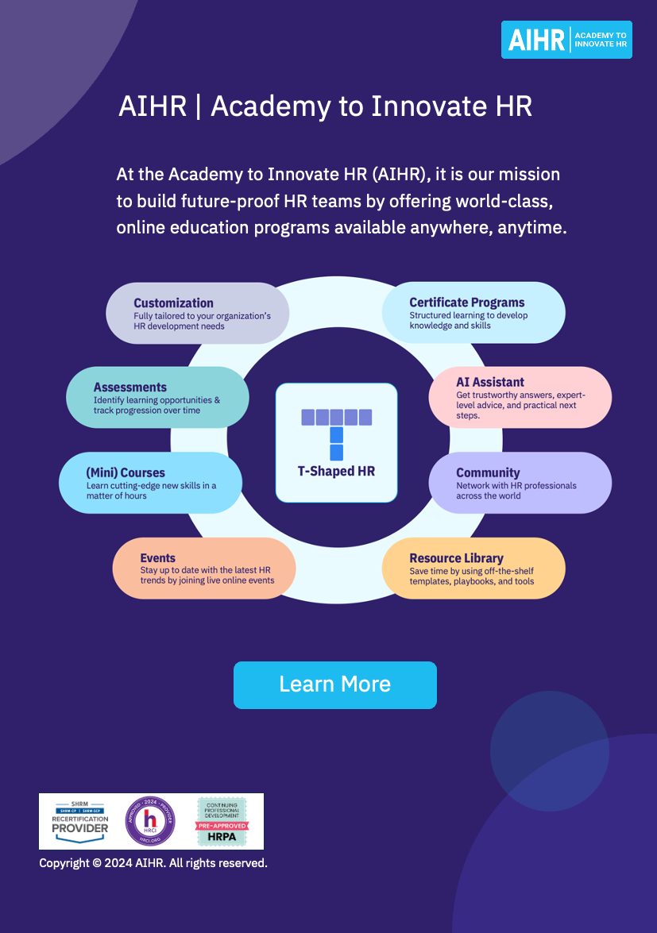](https://www.aihr.com/business/?utm_source=resource&utm_medium=resource&utm_campaign=templates&utm_content=templates)